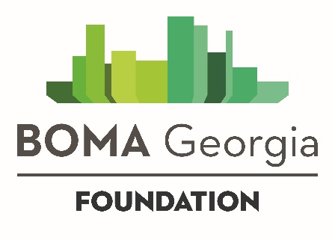
SCHOLARSHIP APPLICATION
First Name:
Last Name:
Company (if available):
Check this box if you are currently unemployed
Email:
Phone:

Tell us more about the scholarship you are seeking. Select from the dropdown box below the scholarship for which you are applying. If applying for multiple scholarships, please complete a separate scholarship application.
AVAILABLE SCHOLARSHIPS  BOMI RPA and FMA Course - $500 Scholarship  Design, Operations and Maintenance Part II – August 1-3  Real Estate Investment and Finance – October 3-5  Property Management 101 - $300 Scholarship  Course Beginning September 7  Commercial HVAC Module - $300 Scholarship  Module 3 Beginning April 5  Foundation of Building Engineering - $185 Scholarship  Begins September 14 | Select the Course you are applying for from the dropdown menu:  DID YOU KNOW?  Registrants for most SMT/SMA Courses, the BOMI High-Performance Sustainable Buildings Program courses, Design Operation and Maintenance of Buildings I, Environmental Health and Safety and the Budgeting and Accounting RPA/FMA course automatically receive a $500 scholarship. This allows BOMA Georgia members to attend these select courses for $589 per course instead of $1,089, and non-members can attend for $809 per course instead of $1,309.

Please answer the following questions as part of your scholarship application:
Since there is limited foundation funding, responses to questions in this application should reflect attention to detail, a genuine need, and thorough responses. Only typed applications will be considered. Handwritten submissions will not be reviewed.

Summarize your experience in the real estate industry.
(2,700 characters; approximately 500 words)

If you are awarded this scholarship, what impact would it have on your career?
(2,700 characters; approximately 500 words)

If you are awarded this scholarship, what benefits will it have for your company/property?
(2,700 characters; approximately 500 words)

BOMA Georgia Foundation scholarships fund up to 50 percent of the cost of courses. If you are awarded a scholarship, how will you obtain funding for the other 50 percent of the cost?
(500 characters; approximately 100 words)

How much money does your employer budget annually for your continuing education?

Have you been awarded a scholarship by the BOMA Georgia Foundation in the past? If so, describe the scholarship(s) as well as the dollar amount(s) and date(s) awarded.

All scholarship applications will be reviewed anonymously by the selection committee. Individual and company name will be redacted during the review process.

I agree to complete the course for which my scholarship is awarded within the timeframe set by the BOMA Georgia Foundation. If the course in which I enroll has an exam, I will assume responsibility for any fees associated with re-testing should I not pass on the first and subsequent attempts.

Return this form by email to the attention of BOMA Georgia Foundation Executive Director Gabriel Eckert.
geckert@bomageorgia.org
Questions? Call (404) 475-9980

